HOW TO ACCESS AND USE THE BCC LIBRARY’S RESOURCES
AND DATABASES
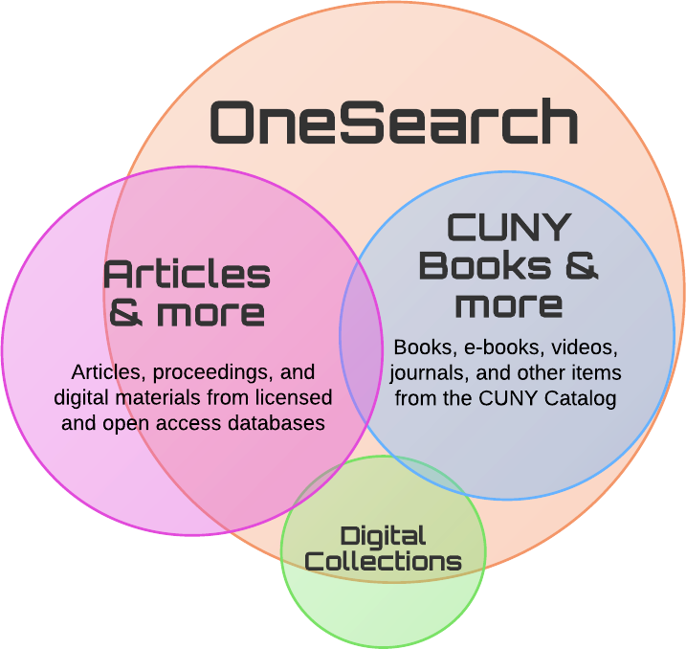

Use OneSearch, the library's catalog to find books, articles, DVDs, CDs, and more.
Use OneSearch if you:
- are looking for a specific title, whether an article or a book,
- want a combination of books, articles, ebooks, etc. on a topic, or
- are just starting your research.
- CUNY OneSearch Video - Overview
https://www.youtube.com/watch?v=pEKWbiJsUHM&feature=youtu.be

Performing Basic Searches:
- Just type one or more words you are looking for and click the Search button.
- To search for a phrase, type quotation marks around the phrase. You can combine both words and phrases in your search.
- Once you are familiar with the basic search, you might want to try doing more with the Search panel or use the Advanced Search option. Both options offer numerous features for making your searches more precise and enable you to get results that are more useful.
- Use the right-hand side panel to narrow down your search by selecting "Resource Type", "Topic/Subject", "Date", and so on.
What are scholarly articles?
Scholarly articles are written by researchers, professors, or students and are published in research or academic journals. Scholarly articles (also known as peer-reviewed or refereed articles) have the highest level of credibility because they have been put through a rigorous system of review as other experts in the author's field of research check the article for accuracy. Because scholarly articles represent high quality research and rigorous review, be sure to include them in your research.
Using Library Research Databases to Locate Scholarly Articles
The BCC Library provides access to over 100 research databases containing tens of thousands of full-text scholarly and professional articles, as well as reports, statistics, case studies, book chapters and some complete books in a wide range of subject areas. Using library research databases will give you higher quality, more focused results than you will find by only going to a Web search engine such as Google and Yahoo.

Picking Your Topic IS part of the Research Process LibGuide
“You have a research paper on a topic of your interest. Your professor has strict parameters for the structure of the paper as well as the type of research you can use (peer-review journals, newspaper articles, etc.) You decided want to do a paper on ‘social media’. Great! Right? So, this means you can get started on your research and start writing your paper, this is Awesome. Well… NO, this is not exactly how the process really works.
Picking a Topic or Research Question IS ACTUAL RESEARCH and part of the research process. When you first pick a research topic, it isn’t set in stone. It’s just a general idea of something that interest you, that you will test with some exploratory research. If you like the results you are finding and it seems to provide answers to the questions you are trying to answer in your paper, then it looks like you can continue to find additional sources and start your paper. HOWEVER, if you are finding very limited results or too big a range of results, then now is the time to tweak your topic choice or even change it completely”.
The above LibGuide link will assist you through the 'Topic' selection process. Once you look this “Guide” over you can proceed to the next step in the research process.
From the library homepage, click on ARTICLES/DATABASES, then click on SEARCH box.
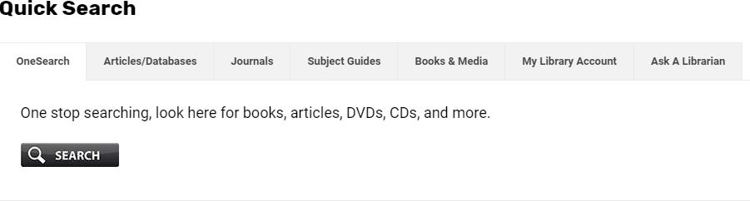

How do I access library databases off-campus?
- Go to the A-Z Databases page.
- Select a database
- Enter your CUNY login credentials, firstname.lastname##@login.cuny.edu + your password​. EXAMPLE: john.doe45@login.cuny.edu + password.
*Please note: Your library account must be activated in order to access resources off-campus, visit the Library's circulation desk. Library fines have been suspended until further notice due to the PANDEMIC.
For remote reference please use Ask-A-Librarian or reference@bcc.cuny.edu for further assistance.
SOME COMMONLY USED DATABASES
• Academic Search Complete
All available databases subscribed to from EBSCOhost.

• Literary Sources (GALE)
A research environment that integrates formerly disparate Gale digital collections; search Gale Virtual Reference Library, Literature Resource Center, Modern Language Association (MLA) International Bibliography and Twayne's Authors Series simultaneously.

• CQ Researcher
Provides award winning in-depth coverage of the most important issues of the day. Our reports are written by experienced journalists, footnoted and professionally fact-checked. Full-length articles include an overview, historical background, chronology, pro/con feature, plus resources for additional research.

- Credo Reference
Encyclopedias, dictionaries, thesauri and books of quotations, and a range of subject-specific titles covering everything from art to accountancy and literature to law.

- Opposing Viewpoints in Context (GALE)
Provides contextual information and opinions on social issues. Features updated viewpoints, topic overviews, full-text magazine, journal and news articles, primary sources, statistics, images, videos, audio files and links to vetted websites.

Bronx Community College Library - Learning Services: Resources for Students and Faculty

Take a look at this link for more important information to help you succeed in your studies and research.

https://bcc-cuny.libguides.com/c.php?g=1067761&p=7770336

HOW TO EVALUATE A WEB SOURCE

You can ask the following questions to determine if a source is credible.
- Who is the author? Credible sources are written by authors respected in their fields of study. Responsible, credible authors will cite their sources so that you can check the accuracy of and support for what they've written. (This is also a good way to find more sources for your own research.)
- How recent is the source? The choice to seek recent sources depends on your topic. While sources on the American Civil War may be decades old and still contain accurate information, sources on information technologies, or other areas that are experiencing rapid changes, need to be much more current.
- What is the author's purpose? When deciding which sources to use, you should take the purpose or point of view of the author into consideration. Is the author presenting a neutral, objective view of a topic? Or is the author advocating one specific view of a topic? Who is funding the research or writing of this source? A source written from a particular point of view may be credible; however, you need to be careful that your sources don't limit your coverage of a topic to one side of a debate.
- What type of sources does your audience value? If you are writing for a professional or academic audience, they may value peer-reviewed journals as the most credible sources of information. If you are writing for a group of residents in your hometown, they might be more comfortable with mainstream sources, such as Time or Newsweek. A younger audience may be more accepting of information found on the Internet than an older audience might be.
- Be especially careful when evaluating Internet sources! Never use Web sites where an author cannot be determined, unless the site is associated with a reputable institution such as a respected university, a credible media outlet, government program or department, or well-known non-governmental organizations. Beware of using sites like Wikipedia, which are collaboratively developed by users. Because anyone can add or change content, the validity of information on such sites may not meet the standards for academic research.

Check the domain type, as it might influence the nature of the information you are viewing.
- Commercial sites usually end in .com. They might be trying to sell you something or promote their own product, so beware of self-promotional language and potentially incomplete or biased information or statistics.
- Academic sites end in Edu. but examine the URL and the page's content. Is it a library web page, or a student's personal project?
- Government-related sites end in .gov. These are generally reliable because the document is from a U.S. government-affiliated site. Keep in mind that reports, data and statistics, and official documents may be more reliable than general interest pages.
- Non-profit groups such as public interest organizations, religious groups, and think tanks use the .org domain. These sites may be biased toward the organization's point of view.
Still have questions? No worries. Contact me at: laroi.lawton@bcc.cuny.edu or go to Ask-A-Librarian

LaRoi Lawton | Assistant Professor
Bronx Community College | Library Department
Learning Services Head | e: laroi.lawton@bcc.cuny.edu

